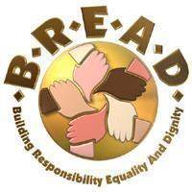
As people of faith, we will push for…

Laws to protect renters!
Laws to protect trees!

Join us and stand together for justice!

Tuesday, May 13, 2025

Program from 6:40 pm to 8:30 pm

At the Celeste Center on the Ohio State Fairgrounds (No charge for parking) 717 E. 17th Ave. (Enter from either direction on 17th Ave,)

- Registration begins at 6:15 pm, Opening remarks at 6:40 pm

- Please come with your tickets COMPLETELY FILLED OUT

The first entrance will be for IMMUNOCOMPROMISED and Mobility Challenged ONLY. We ask that everyone else please use the other doors.

- If you do not have a handicapped placard but still have walking challenges, please place a pink sheet of paper on your car dashboard; and the parking team will direct you to the PINK lot closest to the entrance.

- Additional tickets will be available if necessary.

- There will be a MASK ONLY section for those who would feel more comfortable.

- This venue holds 10,000 people, so there is plenty of room to spread out.

If you are not feeling well, please wear a mask and sit in the bleachers.

The Schmidts concession stand with snacks will be open.

- Childcare WILL be provided for children out of diapers and up to age 8.

What to Expect at the Nehemiah Action:

- You will be joined by THOUSANDS of people fighting for justice on community problems BREAD has voted to take on.

- Our POWER lies in the number of people at the Nehemiah Action speaking in one voice.

- BREAD research committees have met with professionals and agencies in the field for months before deciding on the best possible solution and the appropriate decision-maker with the power to make the change..

- Public officials were given an opportunity to see the questions PRIOR to being on stage that night.

- Your presence is more than just a number. By showing solidarity & being a respectful audience member, you let our spokespeople know that you have their back.

- For questions, please call the BREAD office at 614-220-9363

BREAD Organization

BREAD stands for Building Responsibility, Equality and Dignity. BREAD is a justice ministry organization of 42 congregations and faith communities in central Ohio. The mission is to build the power of people of faith to solve community problems.
Congregations are religiously, racially, and economically diverse. BREAD is a non-profit, non-partisan organization.
BREAD brings people of faith together to put faith into action working for justice. The organization does not provide direct services to individuals, rather, it solves the underlying problems that plague our communities and cause the need for direct services. To be successful at doing justice we have to build the power necessary to hold community leaders accountable. We exercise our power by bringing thousands of community members together from 42 congregations at our annual Nehemiah Action Assembly to press decision-makers for specific commitments to tackle community problems.

What has BREAD accomplished?
  - An additional $1 million has been invested for expanded care for people suffering from mental illness.
  - Got Columbus and Franklin County to form and fund the Affordable Housing Trust Fund, which has financed the development of over 13,000 units of affordable housing.
  - Got Judge Elizabeth Gill to implement and establish “Restorative Justice Circles” in 9 neighborhoods throughout the county to divert non-violent, youth offenders out of the court system.

Most Recently:
  - Got the Dept. of Public Safety to create the Columbus Violence Reduction initiative. In the past year 168 known members of violent groups/gangs have heard the CVR message and 88 are currently safe, alive and out of prison.
  - Got the Chief of the Columbus Police Dept. to train 1,800 officers in Active, Bystandership for Law Enforcement Training (A.B.L.E.) to prepare officers to successfully intervene to prevent harm and to create a law enforcement culture that supports peer intervention.

What is a Justice Ministry/Rodef Tzedek Network Member?

They are the backbone of BREAD! Our work would not be possible without them. You can become a network member anytime of the year by making the following commitments:
  - Attend the four major assemblies each year: the Annual Assembly, the Rally, the Nehemiah Action, and the Celebration;
  - Bring 3 or more people with you to the Nehemiah Action; and
  - Consider investing $200 or more in the work of justice (invitation, not requirement).
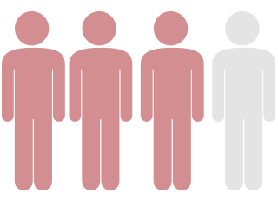

If you are interested in becoming a network member, talk to a team member or organizer today!

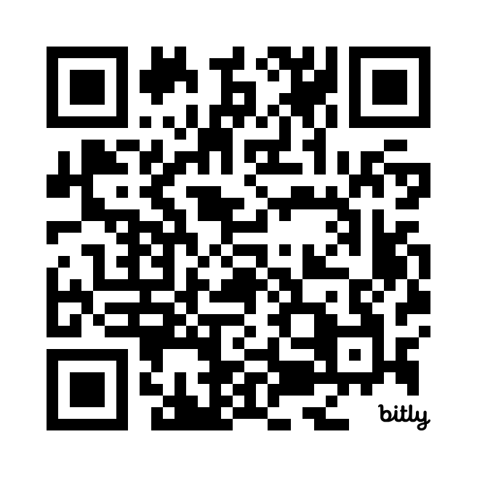
Learn more at www.breadcolumbus.com and follow BreadOrganization on Facebook or breadorg on Instagram for updates! Scan the QR Code for FAQ on getting involved.

